Network Setup

The first thing I did was install net-tools on both server

CentOs $ sudo yum install net-tools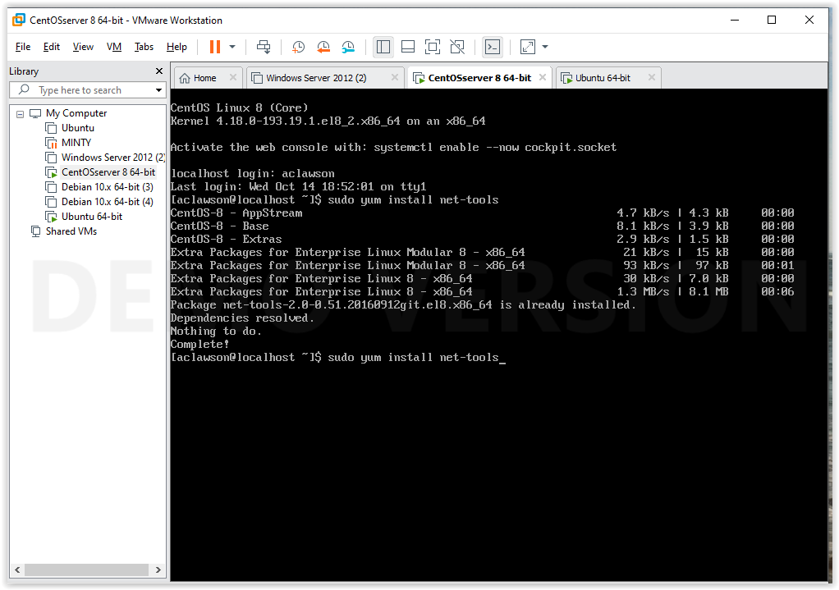

Ubuntu $ sudo apt install net-tools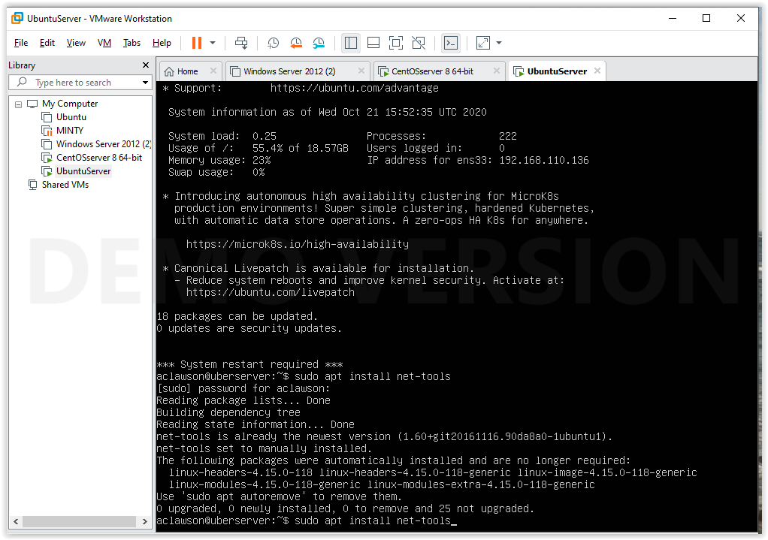

I also installed on both servers ifup and ifdown

Traceroute

tcptrack

The next thing in CentOS was to check to make sure that a static IP address was configured. I ran the ifconfig -a to display the active network which is ens33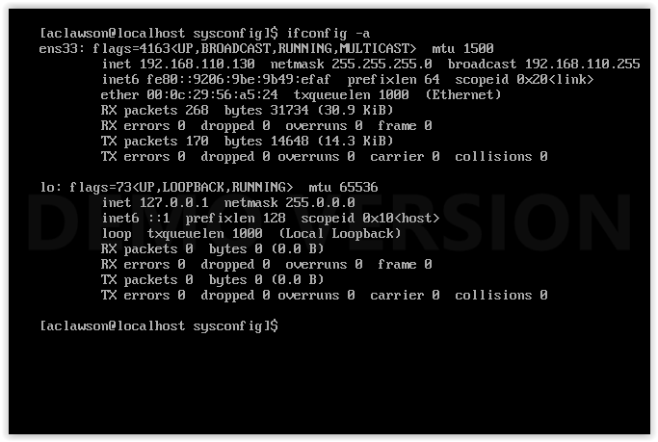

Next to make sure the address was static I run an ifconfig command $ sudo ifconfig ens33 192.168.110.130 netmask 255.255.255.0 broadcast 192.168.110.255. Using the defaults that the network was already using (as to not mess anything up) but configuring those with the command will ensure that the IP is not changed if the system is restarted.

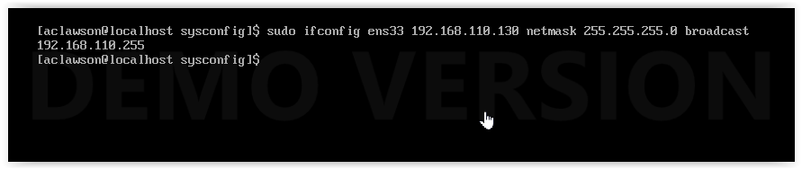

I ran the same command in Ubuntu but with the Ubuntu servers defaults but first in Ubuntu I had to activate the Network using the command $ sudo ifconfig ens33 #(the name of the interface) up 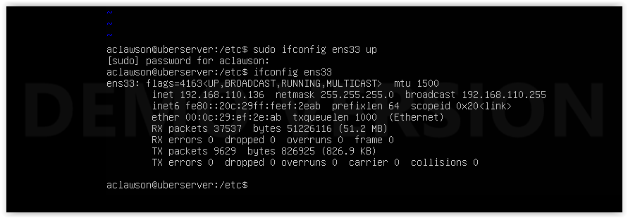

Then I ran the command $ $ sudo ifconfig ens33 192.168.110.136

netmask 255.255.255.0 broadcast 192.168.110.255

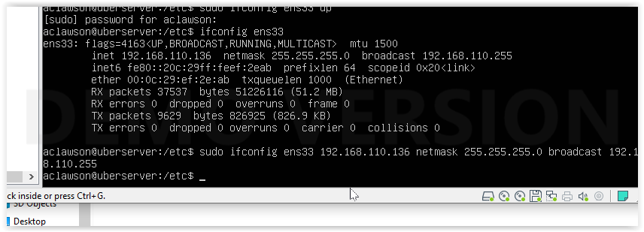

I then install Network Manager and Wireshark on Ubuntu $ sudo apt install wireshark

$ sudo apt install network-manager

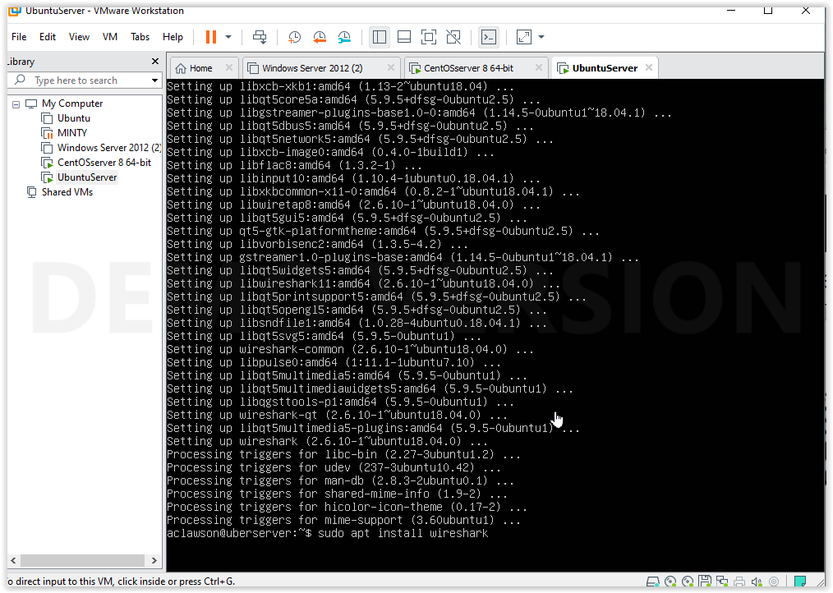

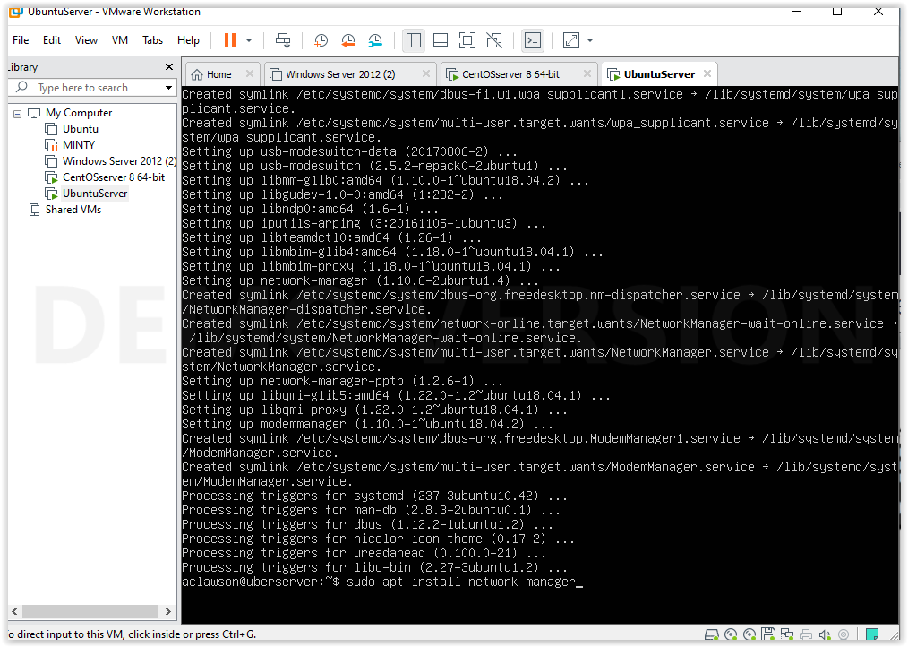

Networks Manager was already install on CentOS but I did install wireshark with $ sudo yum install wireshark

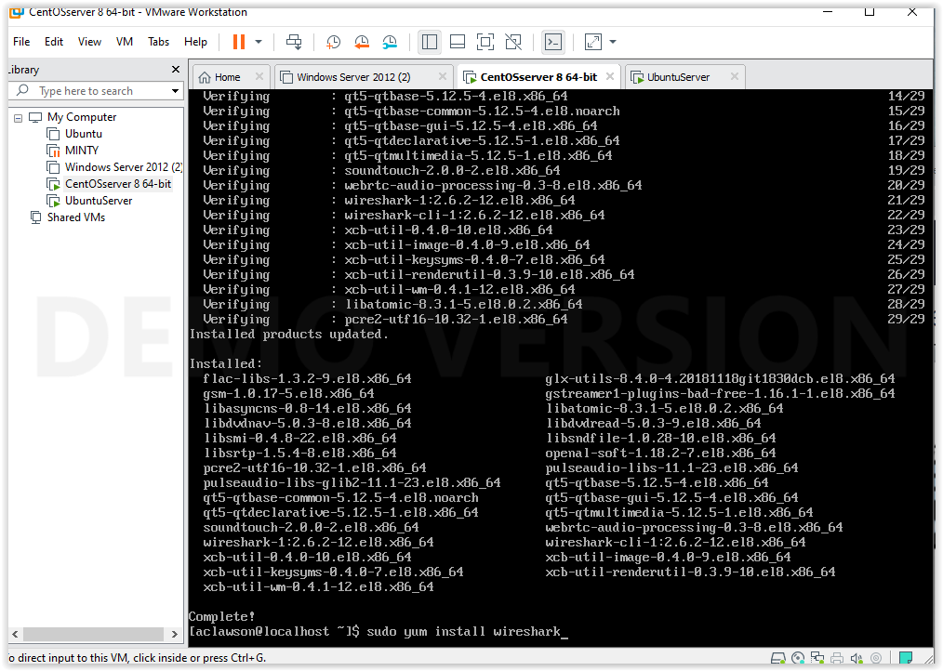

Script instructions

The scripts are both called network.sh

To run the script be in the home directory and run the command $ ./network.sh

This will output the info obtained by the script on to the command line and also save a text file log in the home directory under df.log you can open the file using any text editor you prefer to check the output

GitHub Code [Here](https://github.com/lexboom/LinuxAdmin/blob/main/networks.sh)

Screenshots of Commands running on both servers below.

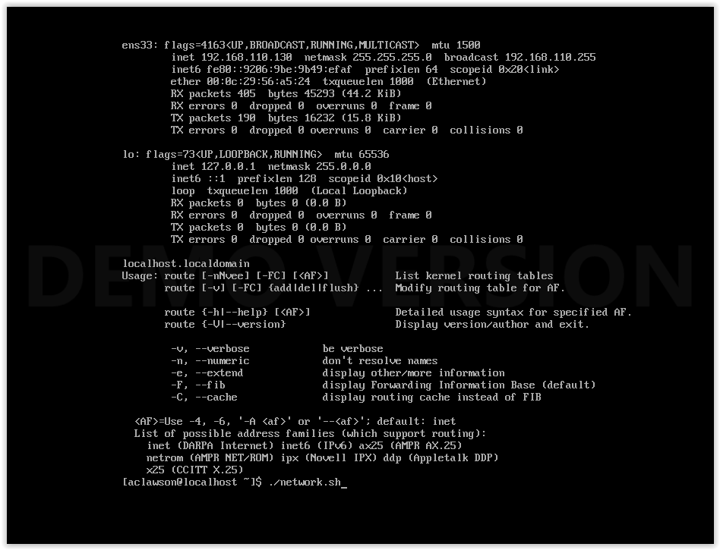

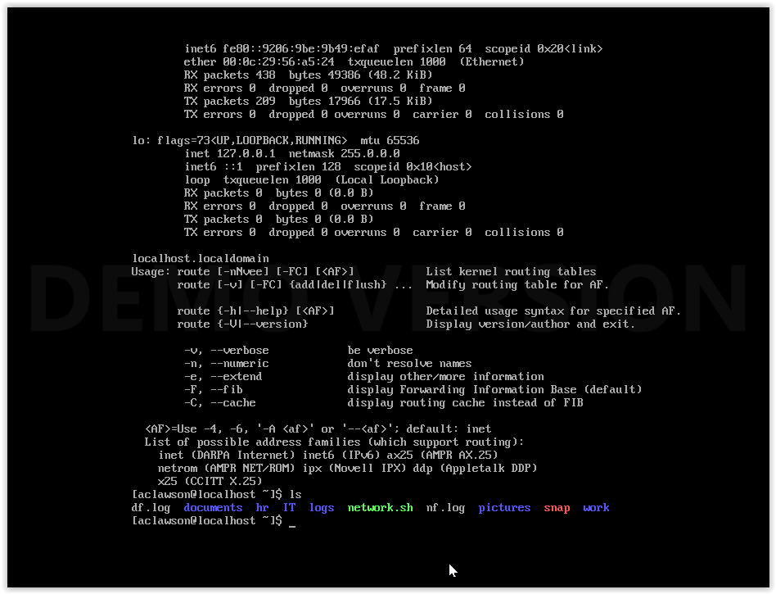

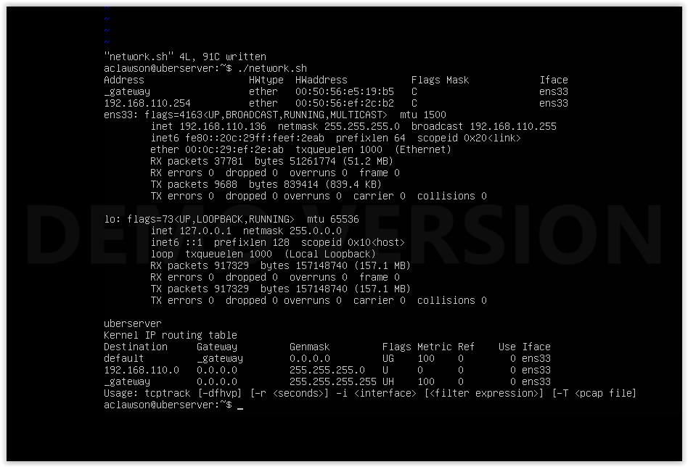

I can check the packages already installed with the command $ dpkg -l

I have a lot of packages installed so I’ am not going to list everything

I have not made any changes to the defaults except samba but I have a whole lab documenting that process

I ran an update today 10/28/2020